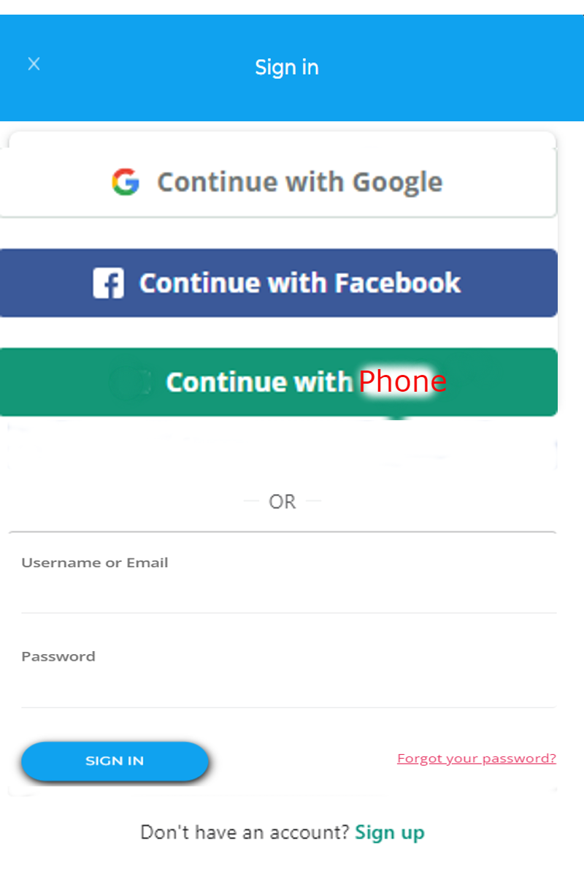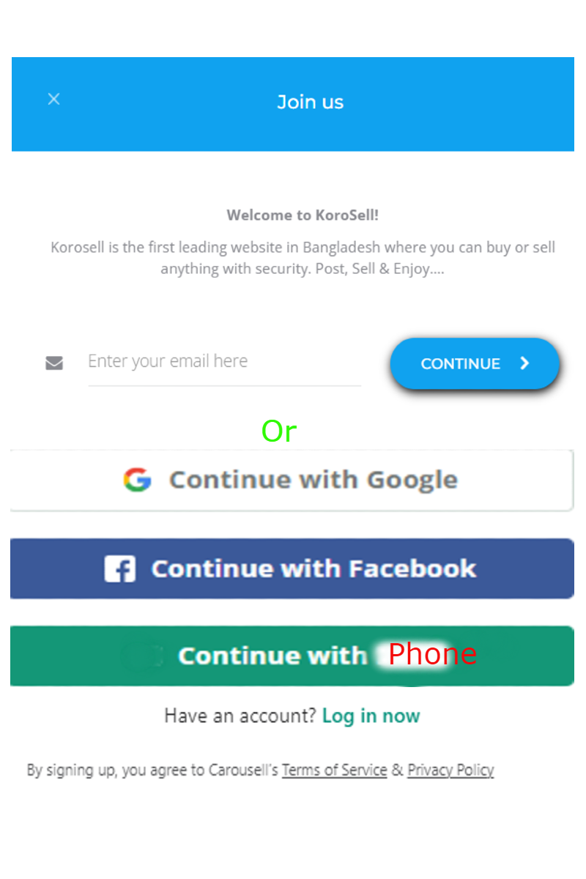

1. Sign In Pop Up & Sign Up Pop Up display . I want to show the google, facebook buttons like these.

"Continue with Phone" button should link up with this link :

https://korosell/login-signup/

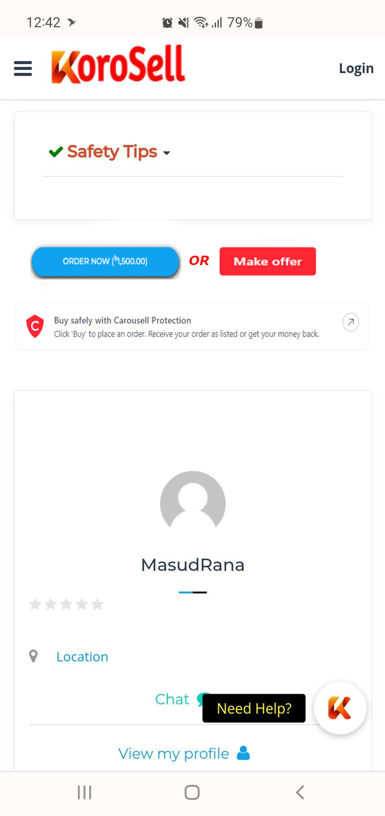

2. Order now button & Make offer button in Aside Block . The buttons should in rectangular style. And I want to show a text block below of the buttons . I will provide the text and logo . When anyone click on it , it will go to another page.

3. I want to show total reviews for all ADs of an users in profile page and Job section single profile section.

a. In user profile page , I want to show total reviews of this user. There will be two tab , one for Listings and another for Reviews. It may be in the style I marked in the below image . Let me know if it makes sense.

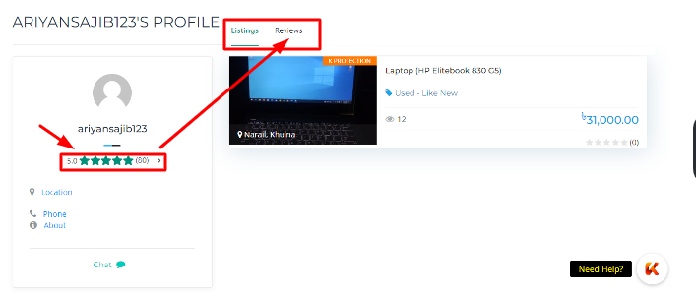

B. Single profile section will just show the reviews number of this user and when anyone click on it , it will go to above profile reviews section.

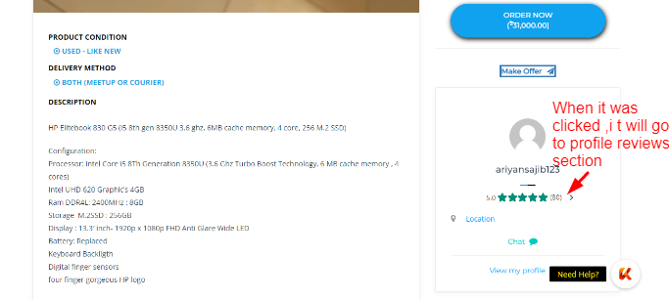

C. My profile page also need to show a section of the user total reviews

Like this :

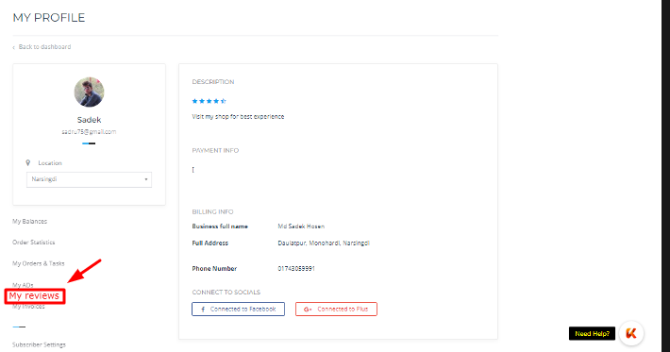

4. I want to put a separate section for featured ads

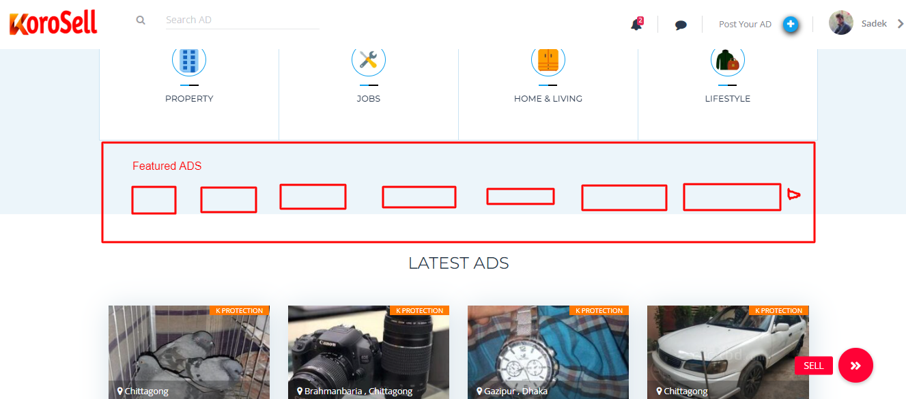

<https://youtu.be/CGKelQHwgRQ> , check this video how it works.

(First section which is scrolling right)

5. All Ads(homepage, categories etc) I want to show in 2 columns for mobile screen.

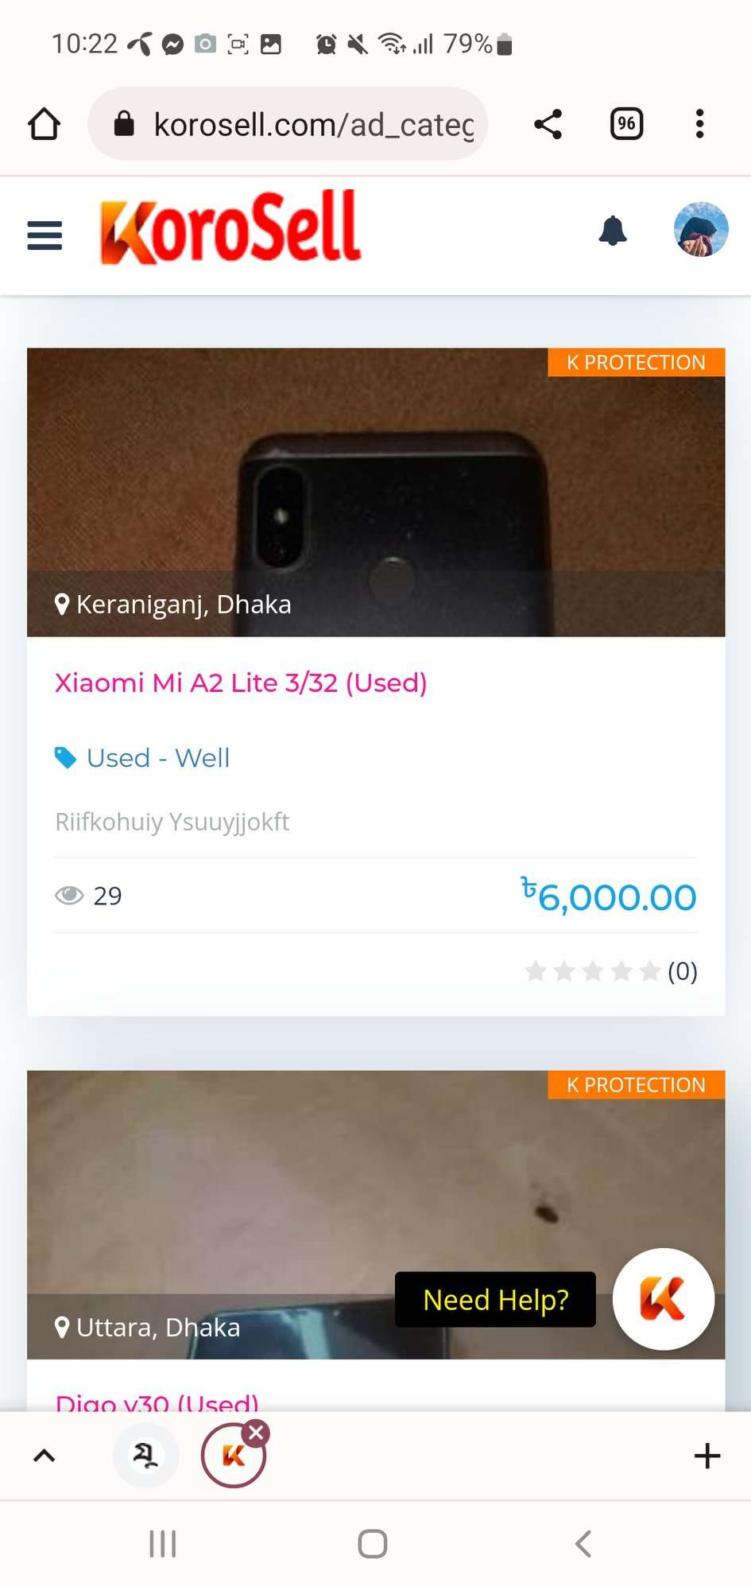

Check video : <https://youtu.be/CGKelQHwgRQ> how it shows in our competitor site.

6. Make sure images are shown well in the thumbnail image.

It seems it is cropped for some reason.(Both in desktop & mobile screen)

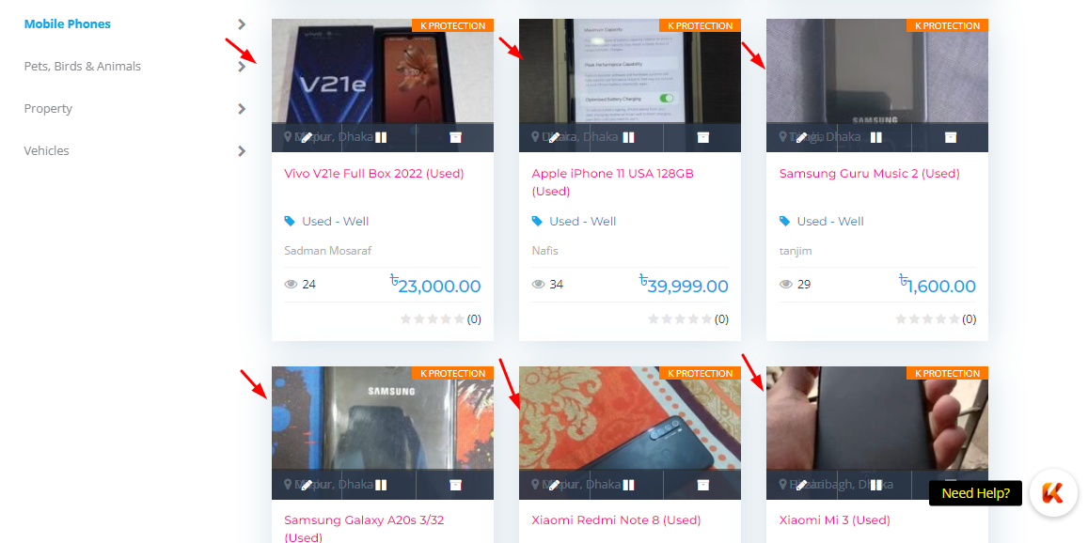

This video is also an example how it looks good :

<https://youtu.be/CGKelQHwgRQ>

7 . Need to add message button in homepage (Described it before)